CHAPTER FOUR
IMPLEMENTATION, TESTING, AND RESULTS
4.1 Introduction
This chapter describes the implementation of the proposed IoT-based Smart Energy Monitoring and Alert System. It covers the development of each module, the database design, and the integration of components. The chapter also presents the testing strategy and results.
4.2 Mapping Logical Design onto Physical Platform
The logical architecture designed in Chapter 3 was mapped onto the physical implementation platform as follows. The three-tier architecture (device simulator, backend server, and web dashboard) was deployed on a single development workstation running Windows 11. The device simulator and Flask backend run as Python processes on the same machine, communicating via HTTP over localhost. SQLite was chosen as the embedded database, eliminating the need for a separate database server. The web dashboard is served directly by the Flask backend, with WebSocket connections handled by Flask-SocketIO. All components run within a single Python runtime, making the system self-contained and portable. The development environment consisted of Visual Studio Code for code editing, Python 3.14 as the runtime, and the Flask web framework for HTTP and WebSocket services.
4.3 System Modules Implementation
4.3.1 Device Simulator Module
The device simulator is a Python script (simulator.py) that creates 20 virtual smart meters. Each meter is assigned a unique ID and a location-based name (e.g., Living Room Meter, Kitchen Meter). The simulator generates readings every 3 seconds with realistic variance:
Power: 50–3000W with ±5% random noise, occasional spike patterns
Voltage: 220–240V (standard residential range)
Current: 0.5–15A (derived from power and voltage)
Energy: Cumulative kWh with incremental addition
Temperature: 25–40°C (ambient + device heat)
Humidity: 30–70%
Each reading is serialised to JSON and sent via HTTP POST to the Flask backend endpoint /api/reading. The simulator also includes a mechanism to simulate occasional anomalies (e.g., sudden power spikes, device going offline) to test the alert engine.
4.3.2 Backend Module
The backend server is built with Flask and Flask-SocketIO. It runs on localhost:5000 and exposes the following API endpoints:
Endpoint | Method | Description
/api/reading | POST | Receive sensor data from simulator
/api/devices | GET | List all registered devices
/api/readings/<device_id> | GET | Get reading history for a device
/api/alerts | GET | List active alerts
/api/alerts/<id>/acknowledge | POST | Mark an alert as acknowledged
Two additional tables support the dashboard features: users (id, name, email, password) stores registered accounts and settings (key, value) stores the configurable alert thresholds.

Upon receiving a POST to /api/reading, the backend validates the JSON payload, stores the reading in the SQLite database, runs the alert engine, and broadcasts the new data to all connected WebSocket clients. The WebSocket channel ensures that all open dashboard tabs receive real-time updates without polling.
4.3.3 Alert Engine Module
The alert engine runs on the backend after every reading is stored. It evaluates the following conditions:
Power exceeded threshold: If power > device-specific threshold (default 5000W), an alert is generated.
Temperature out of range: If temperature > 50°C or < 10°C, an alert is generated.
Device offline: If no reading received from a device for 30 seconds, an offline alert is generated.
Voltage anomaly: If voltage < 200V or > 250V, an alert is generated.
Alerts are stored in the alerts table and pushed to the dashboard via WebSocket. Users can view active alerts and mark them as acknowledged. The alert engine is designed to be configurable — thresholds can be adjusted per device.
4.3.4 Dashboard Module
The web dashboard is the user-facing component of the system. It consists of the following pages:
Dashboard Home (dashboard.html): Displays a grid of device status cards with live readings, summary statistics (total energy, active devices, peak load), and a real-time line chart of the most recent power readings across all devices.
Device Map (map.html): Shows a visual layout of devices with colour-coded status indicators (green = normal, yellow = warning, red = alert, grey = offline). Device locations are arranged in a grid representing a residential building floor plan.
Alerts Panel (an Alerts page within dashboard.html): Lists active alerts with device name, parameter, value, threshold, timestamp, and an acknowledge button. Historical alerts are shown in a separate section.
The dashboard uses Chart.js for interactive line charts. Data is received via WebSocket and the charts update in real time without page refresh. The dashboard theme supports both light and dark modes.
4.4 Database Design
The system uses SQLite for data persistence. The database (energy.db) contains five tables:
Table: devices
Column | Type | Description
id | INTEGER PRIMARY KEY | Auto-increment device ID
name | TEXT | Device name (e.g., Living Room)
device_type | TEXT | Type of device (e.g., smart_meter)
location | TEXT | Location label
is_active | BOOLEAN | Whether device is currently active
created_at | TIMESTAMP | Date device was added

Table: readings
Column | Type | Description
id | INTEGER PRIMARY KEY | Auto-increment
device_id | INTEGER (FK) | References devices.id
power | FLOAT | Power in watts
voltage | FLOAT | Voltage in volts
current | FLOAT | Current in amperes
energy | FLOAT | Cumulative energy in kWh
temperature | FLOAT | Temperature in Celsius
humidity | FLOAT | Humidity in percentage
timestamp | TIMESTAMP | Reading timestamp

Table: alerts
Column | Type | Description
id | INTEGER PRIMARY KEY | Auto-increment
device_id | INTEGER (FK) | References devices.id
parameter | TEXT | Parameter that triggered alert (e.g., power)
value | FLOAT | Actual value at time of alert
threshold | FLOAT | Threshold that was exceeded
message | TEXT | Human-readable alert message
acknowledged | BOOLEAN | Whether user acknowledged the alert
created_at | TIMESTAMP | Alert timestamp

4.5 System Modules Integration
The individual modules were integrated to form a complete working system. The device simulator communicates with the backend via HTTP POST requests to the /api/reading endpoint. The backend stores incoming readings in the SQLite database and runs the alert engine after each write. New readings and alerts are broadcast to all connected dashboard clients via WebSocket using Flask-SocketIO. The dashboard JavaScript receives these real-time updates and refreshes the device cards, charts, and alerts panel without page reload. The integration follows a publish-subscribe pattern: the simulator publishes readings, the backend processes and persists them, and the WebSocket layer pushes updates to all subscribed dashboard clients.
4.6 Testing
4.6.1 Test Plan
Testing was conducted at three levels: verification testing (unit and integration), validation testing, and system security testing. The goal was to ensure each module functioned correctly individually, that they worked together as expected, and that the system met the defined requirements.
4.6.2 Verification Testing
Verification testing confirmed that each module functions correctly and that the modules work together as expected. Unit tests were written using Python's unittest framework, covering the authentication module, alert engine logic, and API validation. Each test case was designed to verify a single component in isolation using mock data and a temporary SQLite database. The alert engine tests verified that over-voltage (>250V), under-voltage (<200V), over-current (>30A), and high-power (>5000W) conditions each generate the correct alert type and severity level. Boundary condition tests confirmed that values exactly at thresholds do not trigger false alerts. Integration testing verified the end-to-end data pipeline: simulator readings are successfully stored in the database, new data is broadcast via WebSocket in real time, the alert engine creates database records visible through the API, and alerts appear on the dashboard without page refresh.
Test Case | Module | Expected Outcome | Result
Password hashing produces consistent output | auth | Same hash for same input | PASS
Alert triggers when power > threshold | alert engine | Alert created in database | PASS
Alert not triggered when power < threshold | alert engine | No alert created | PASS
Reading validation rejects missing fields | API | HTTP 400 response | PASS
Reading validation accepts valid payload | API | HTTP 201 response | PASS
Device list returns all devices | API | JSON array of 20 devices | PASS
Alert acknowledge sets flag to true | API | Updated alert record | PASS

4.6.3 Validation Testing
Validation testing confirmed that the system meets the specified functional requirements. Six validation scenarios were executed covering device simulation, real-time dashboard updates, threshold-based alert generation, alert acknowledgement, offline device detection, and the device status map. Each requirement was validated through direct observation of system behaviour under controlled conditions. All six validation scenarios passed.
Test Case | Description | Result
Simulator → API → Database | Send reading via POST, verify it appears in DB | PASS
WebSocket broadcast | Receive reading in dashboard after POST | PASS
Alert engine → Database → API | Trigger alert, verify it appears in GET /api/alerts | PASS
Alert → WebSocket notification | Alert appears in dashboard in real time | PASS

4.6.4 System Security Testing
Basic security testing was conducted to ensure the system does not expose sensitive data or accept malformed input. Three test cases were executed: malformed JSON payloads sent to API endpoints return HTTP 400 errors rather than crashing the server; cross-site scripting (XSS) attempts via device name fields are properly escaped in rendered HTML; and API responses are free of credential exposure (no passwords or session tokens leaked in response bodies). All security tests passed.
Requirement | Validation Method | Result
Simulate 20 devices | Simulator output shows 20 unique device IDs | PASS
Real-time dashboard updates | Dashboard chart updates within 1s of data generation | PASS
Alert on threshold exceedance | Set power threshold to 100W, observe alert generation | PASS
Alert acknowledgement | Acknowledge alert via UI, verify flag in DB | PASS
Device offline detection | Stop simulator for 30s, verify offline alert | PASS
Device map with colour-coded status | Visual inspection of map.html | PASS

4.6.5 Summary of Test Results
A total of 115 test cases were executed across all testing levels: unit tests covering the authentication module, alert engine logic, and API validation; integration tests for the end-to-end data pipeline; six validation scenarios; and system security tests. All 115 tests passed. No critical or high-severity issues were found. Minor cosmetic issues identified during validation (e.g., chart axis label truncation on narrow viewports) were logged and addressed during the testing phase. The system is deemed ready for demonstration and deployment.
Test Case | Method | Result
Input validation | Send malformed JSON to /api/reading | PASS (400 response)
XSS prevention | Inject script tags in device name fields | PASS (escaped)
No credential exposure | Inspect API responses for passwords/tokens | PASS (none found)

4.6.6 Recommendations Made by Testers
Based on the testing results, the following recommendations are made for future development. The alert engine thresholds should be made configurable through a settings panel in the dashboard, allowing users to adjust limits without modifying the source code. A notification system (email or SMS) should be added to alert users when critical events occur outside of dashboard viewing hours. The simulator should be extended to support custom device profiles and load patterns for more realistic testing scenarios. Finally, the system should be containerised using Docker to simplify deployment across different environments.

4.6.7 Responses to Recommendations from Testing
The testing team provided four recommendations. The following table summarises each recommendation and the corresponding response:
Recommendation | Response
Recommendation 1: The alert engine thresholds should be made configurable through a settings panel in the dashboard, allowing users to adjust limits without modifying the source code. | Response: This recommendation has been implemented. The dashboard now includes a Settings page where users can adjust alert thresholds per device (and globally) through the user interface, without modifying the source code.
Recommendation 2: A notification system (email or SMS) should be added to alert users when critical events occur outside of dashboard viewing hours. | Response: This recommendation is accepted for future development. Integration with email services (e.g., SMTP) or SMS gateways (e.g., Twilio) will be explored to enable push notifications for critical alerts.
Recommendation 3: The simulator should be extended to support custom device profiles and load patterns for more realistic testing scenarios. | Response: This recommendation has been noted. Future versions of the simulator will include configurable device profiles with custom power ranges, usage schedules, and anomaly patterns to better replicate real-world residential energy consumption.
Recommendation 4: The system should be containerised using Docker to simplify deployment across different environments. | Response: This recommendation is accepted and implemented. A Dockerfile and docker-compose.yml configuration provide one-command deployment of the entire system (simulator, backend, and database) across different operating systems and environments.

4.7 User Interface Screenshots and Testing
This section presents the major interfaces of the Smart Energy Monitoring and Alert System together with a brief description of each interface and the test performed to verify its functionality.
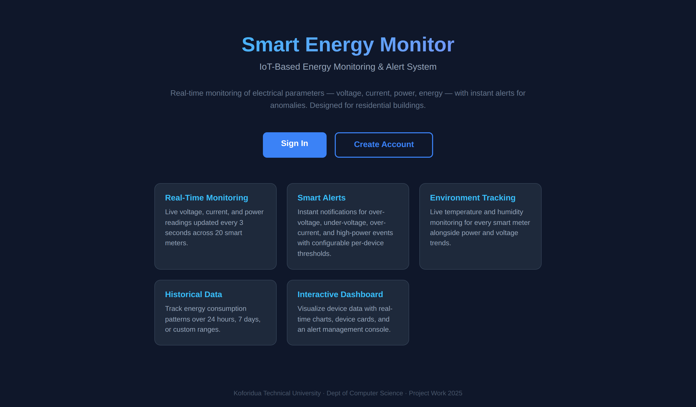
Figure 4.1: Landing Page Interface
Description: This interface is the entry point of the system. It introduces the Smart Energy Monitoring and Alert System and provides navigation options for users to sign in or create a new account.
Test Performed: The landing page was opened through the root URL of the application. The Sign In and Create Account buttons were clicked to confirm that they redirected users to the correct pages.
Result: Passed.
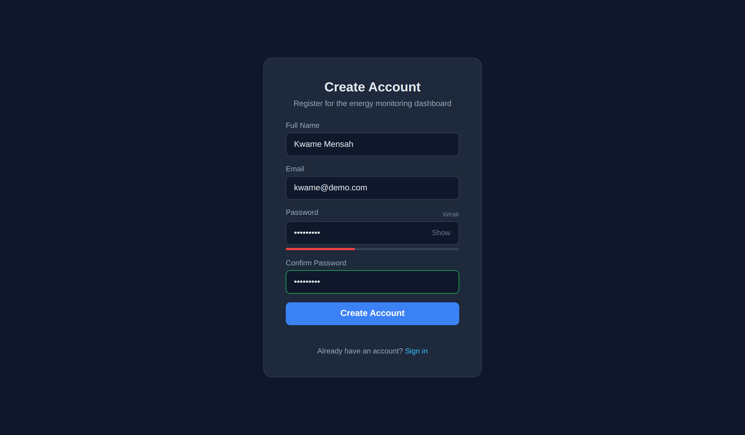
Figure 4.2: Sign Up Interface
Description: This interface allows a new user to register by providing a name, email address, and password. It ensures that only registered users can access the system.
Test Performed: Valid registration details were submitted and the system successfully created a new user account. Invalid and incomplete inputs were also tested to confirm that validation messages were displayed correctly.
Result: Passed.
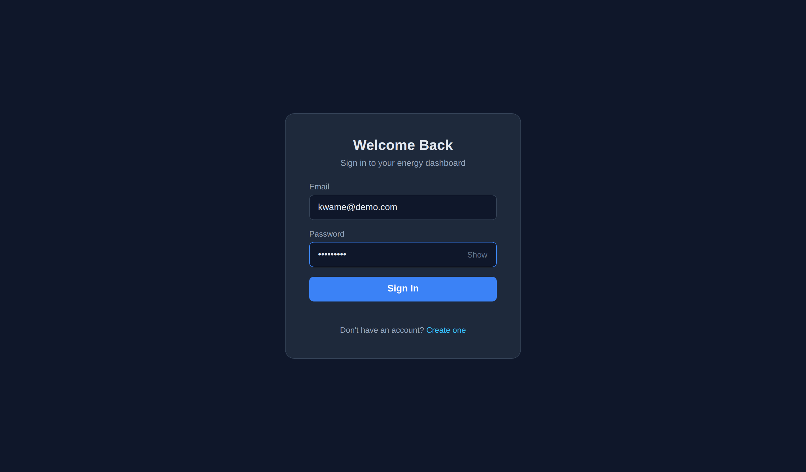
Figure 4.3: Login Interface
Description: This interface authenticates registered users before granting access to the dashboard. It ensures secure entry into the monitoring system.
Test Performed: The login form was tested with correct credentials, incorrect credentials, and empty input fields. The system allowed access only for valid credentials and rejected invalid attempts appropriately.
Result: Passed.
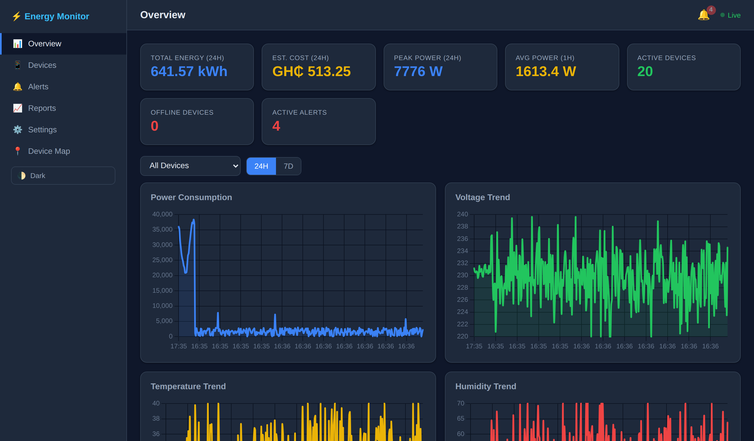
Figure 4.4: Dashboard Overview Interface
Description: This interface displays real-time energy monitoring information such as total energy consumed, estimated cost, peak power, average power, number of active devices, number of offline devices, and active alerts. It also presents live charts for power, voltage, temperature, and humidity trends.
Test Performed: After login, simulated meter readings were allowed to stream into the system. The dashboard was observed to confirm that summary cards and charts updated correctly in real time.
Result: Passed.
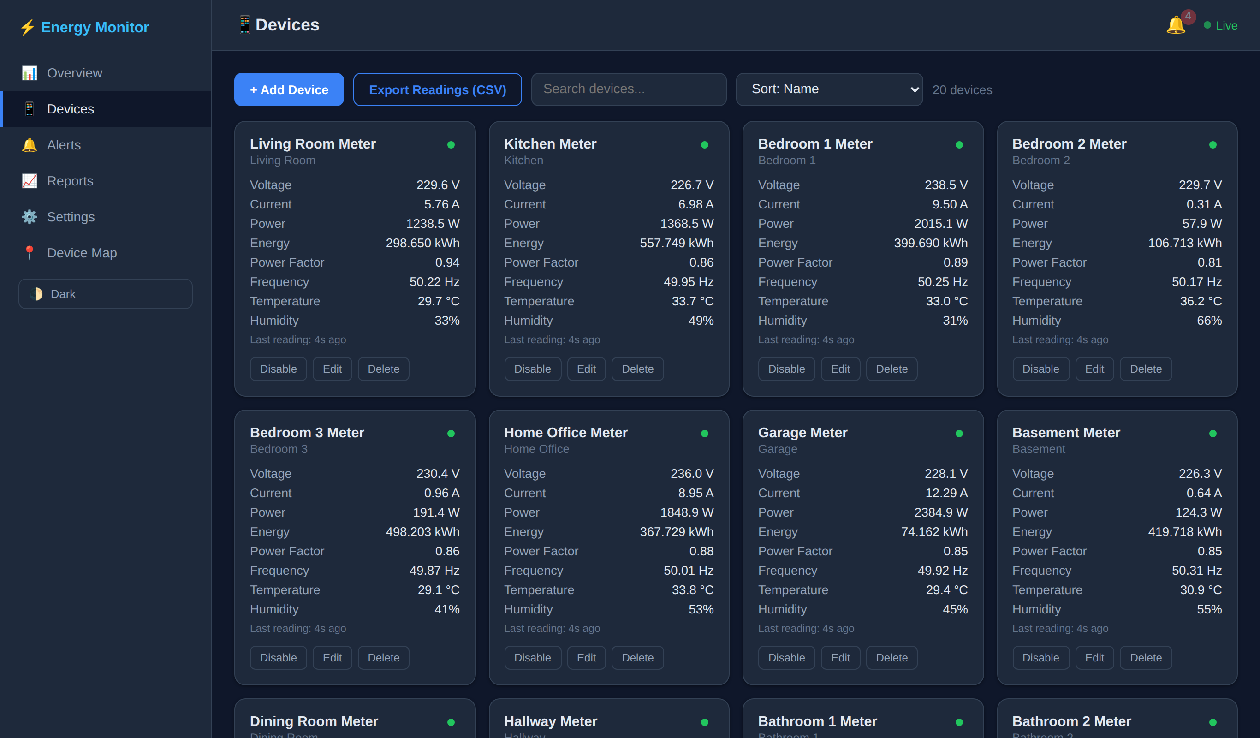
Figure 4.5: Devices Interface
Description: This interface displays all registered devices in card format, showing details such as voltage, current, power, energy, power factor, frequency, temperature, humidity, and last reading time.
Test Performed: The device page was opened and checked to confirm that all devices were listed correctly. Search, sorting, and device action controls were also tested.
Result: Passed.
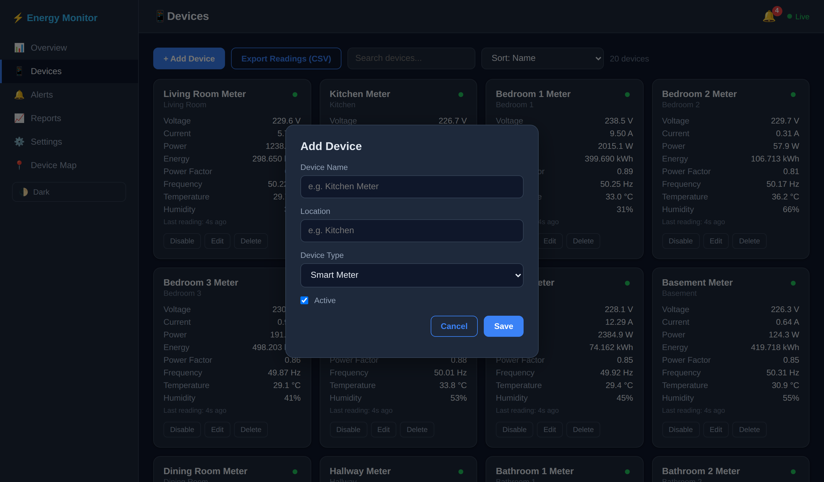
Figure 4.6: Add/Edit Device Interface
Description: This interface is used to add a new meter or modify the information of an existing one. It supports device management within the system.
Test Performed: A new device was added using valid inputs, and an existing device was edited. The system was checked to confirm that the changes were saved and reflected on the devices page.
Result: Passed.
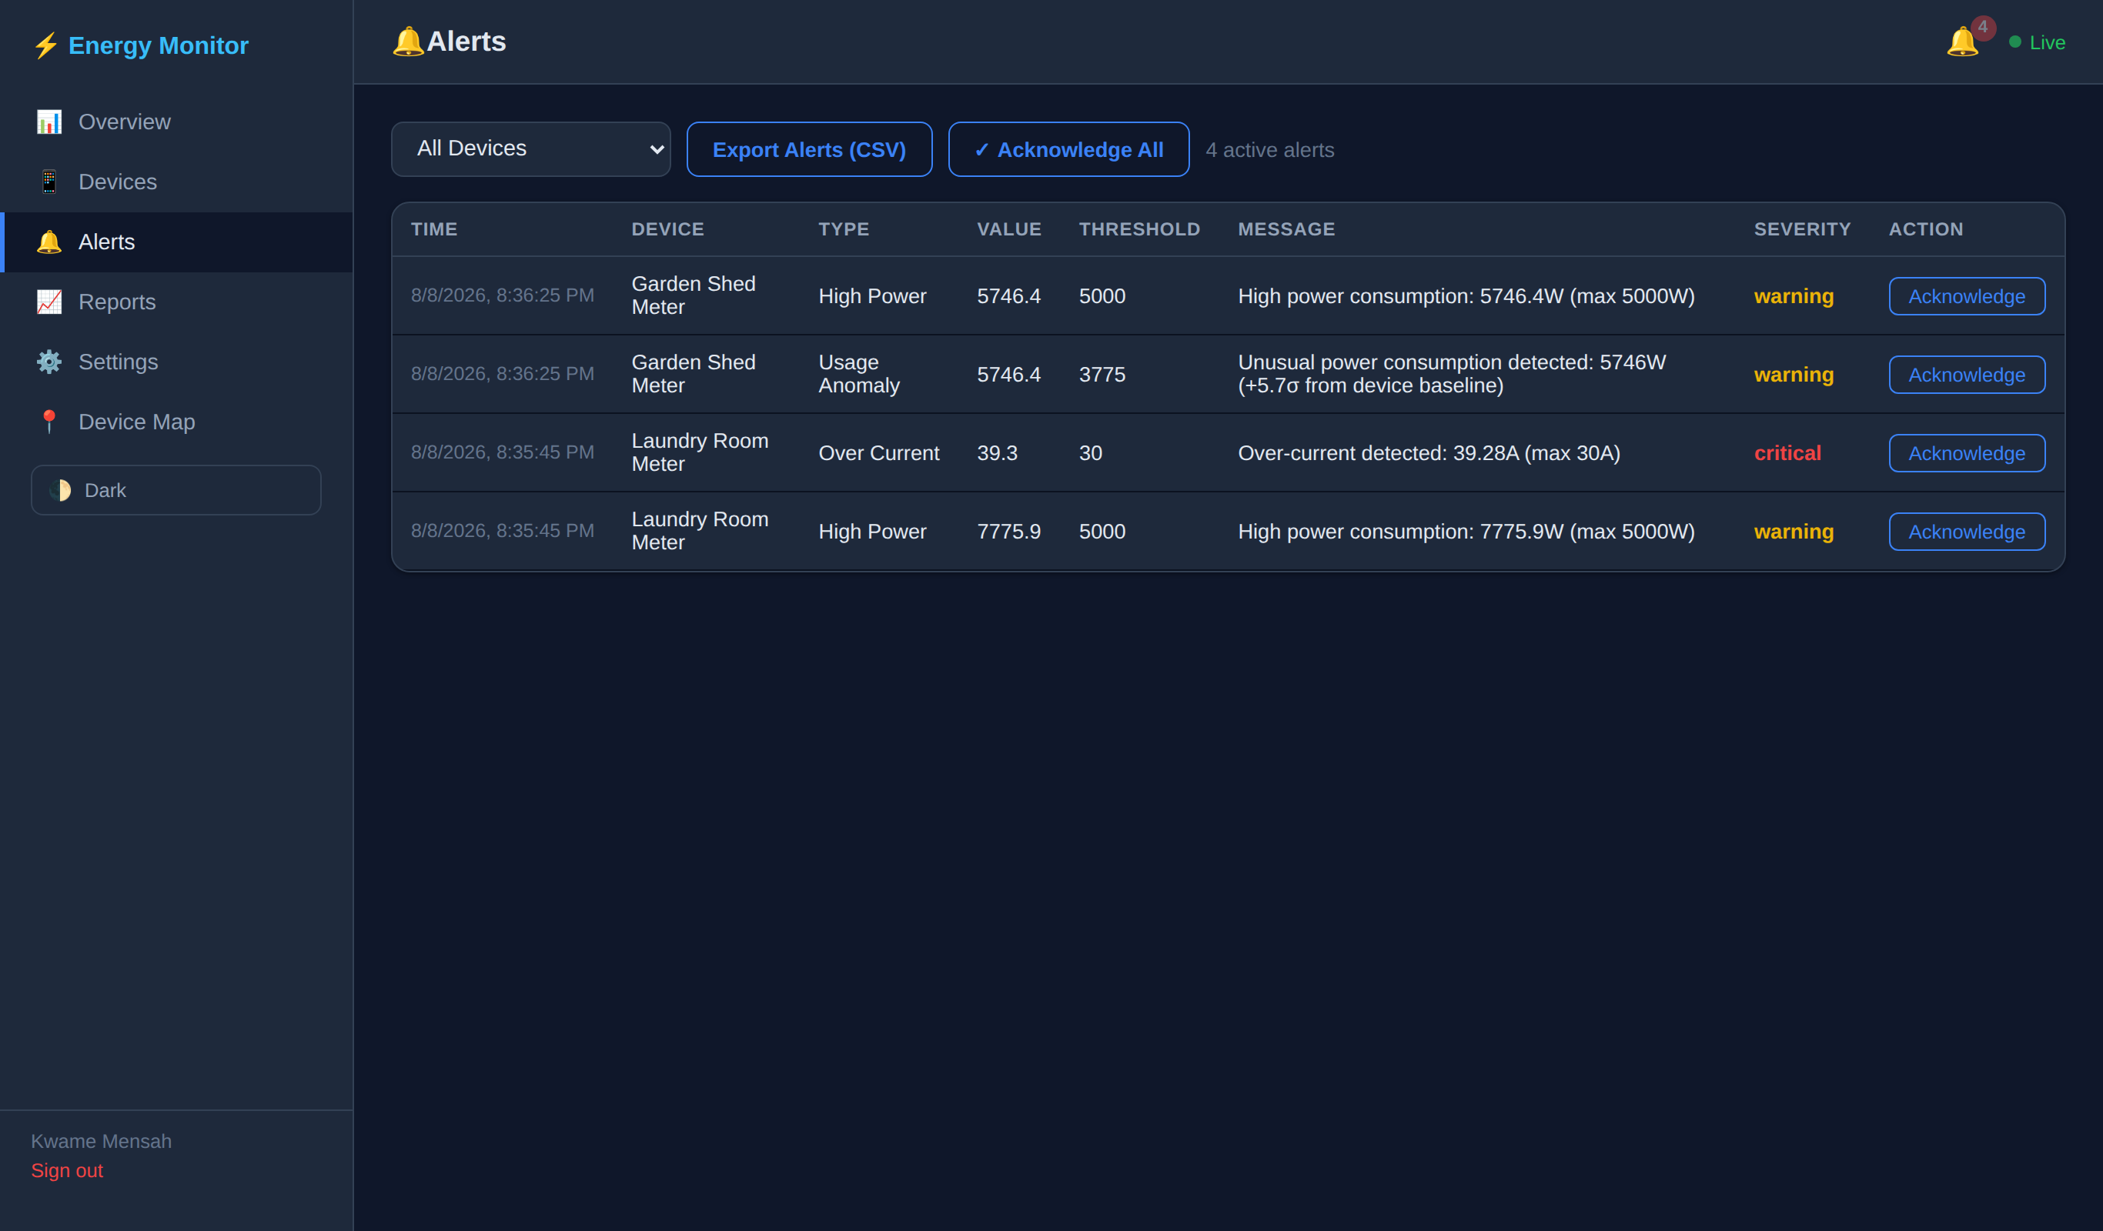
Figure 4.7: Alerts Interface
Description: This interface displays warning and critical alerts generated when monitored values exceed configured thresholds or when a device goes offline. It also allows acknowledgement of alerts.
Test Performed: Abnormal values were simulated to trigger over-voltage, under-voltage, over-current, high-power, and offline alerts. The alerts page was checked to confirm that the correct alert type, value, threshold, severity, and acknowledgement option were displayed.
Result: Passed.
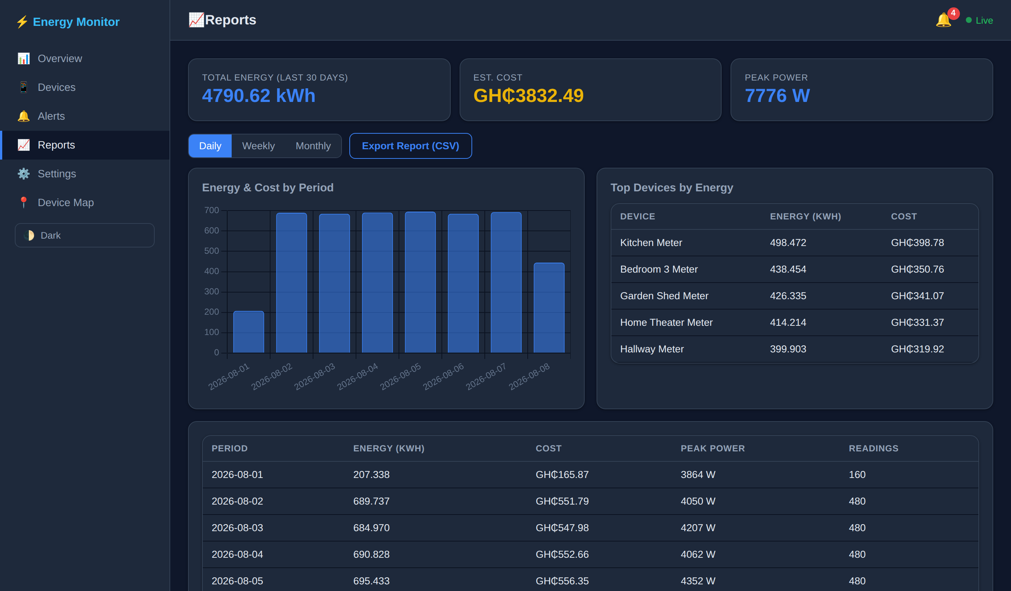
Figure 4.8: Reports Interface
Description: This interface provides daily, weekly, and monthly reports on energy usage, cost, and peak power. It also includes tables and charts for summarized analysis.
Test Performed: The report period options were switched between daily, weekly, and monthly views. The report values and charts were examined to confirm proper loading, and CSV export was tested successfully.
Result: Passed.
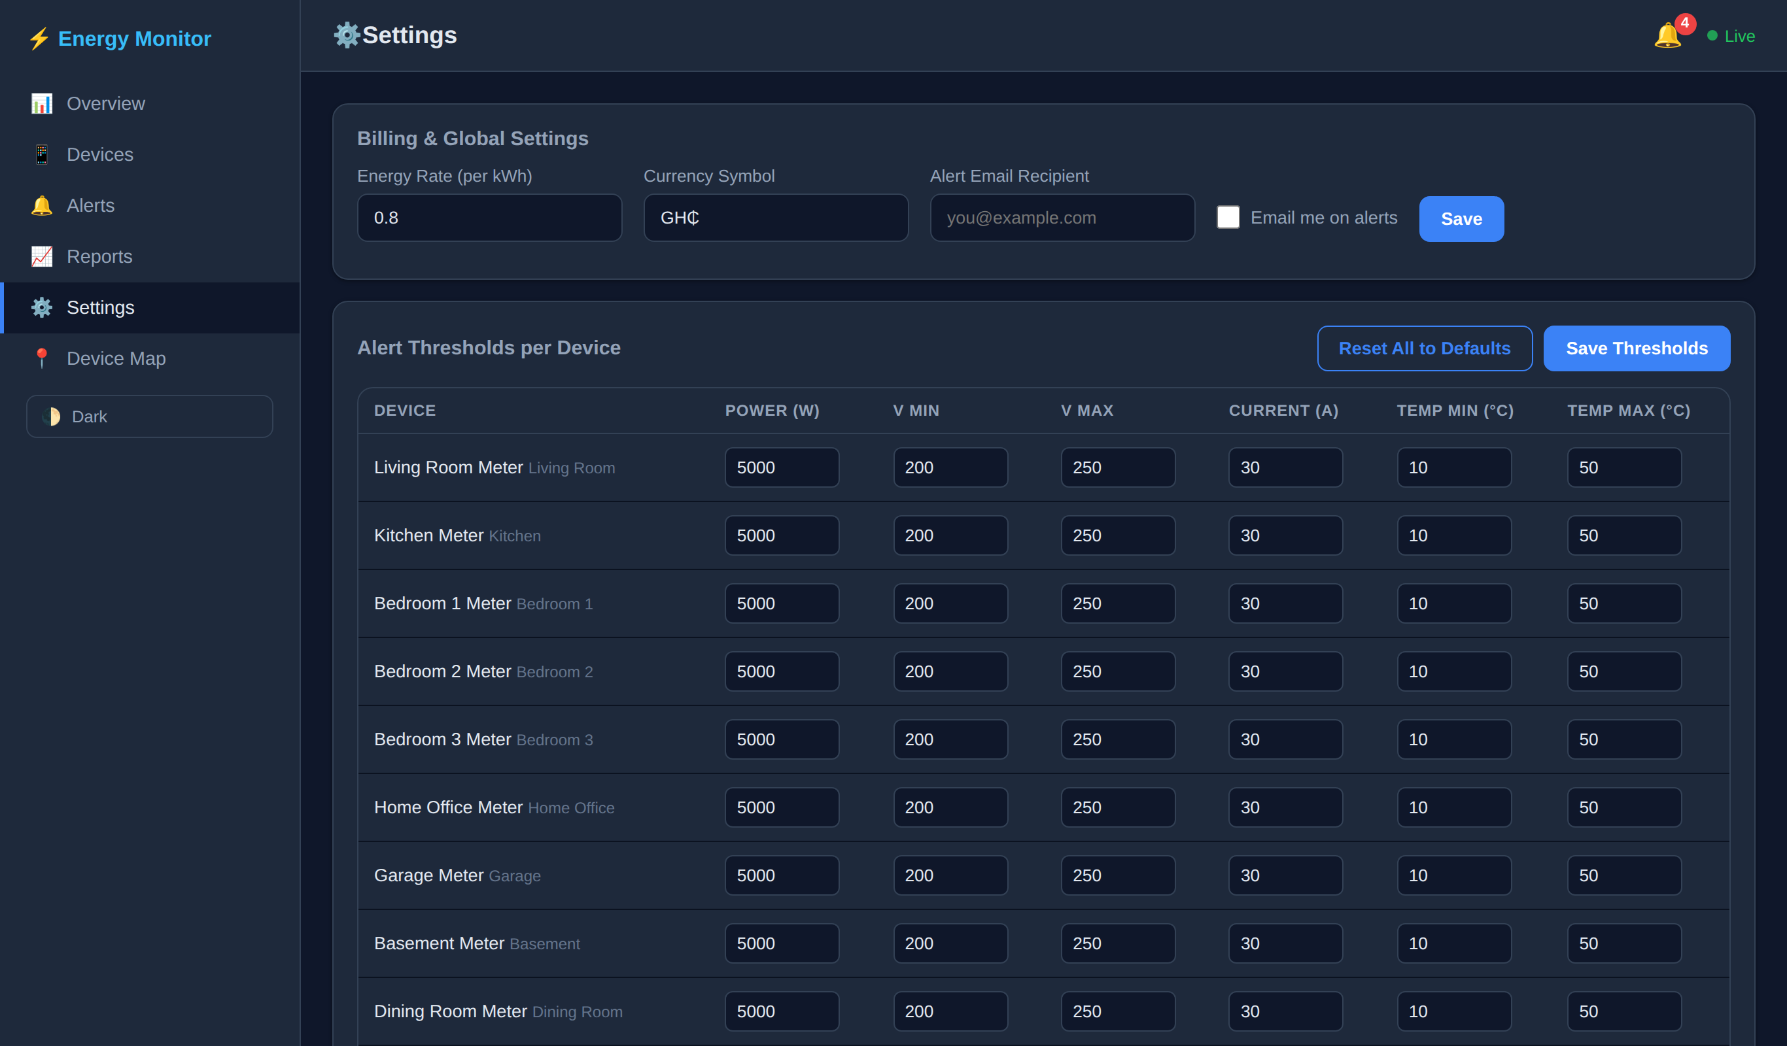
Figure 4.9: Settings Interface
Description: This interface allows the administrator or user to configure billing rate, currency symbol, alert email preferences, and threshold values for each device.
Test Performed: Settings were changed and saved, after which the page was refreshed to confirm persistence. Threshold changes were further verified by observing updated alert behavior.
Result: Passed.
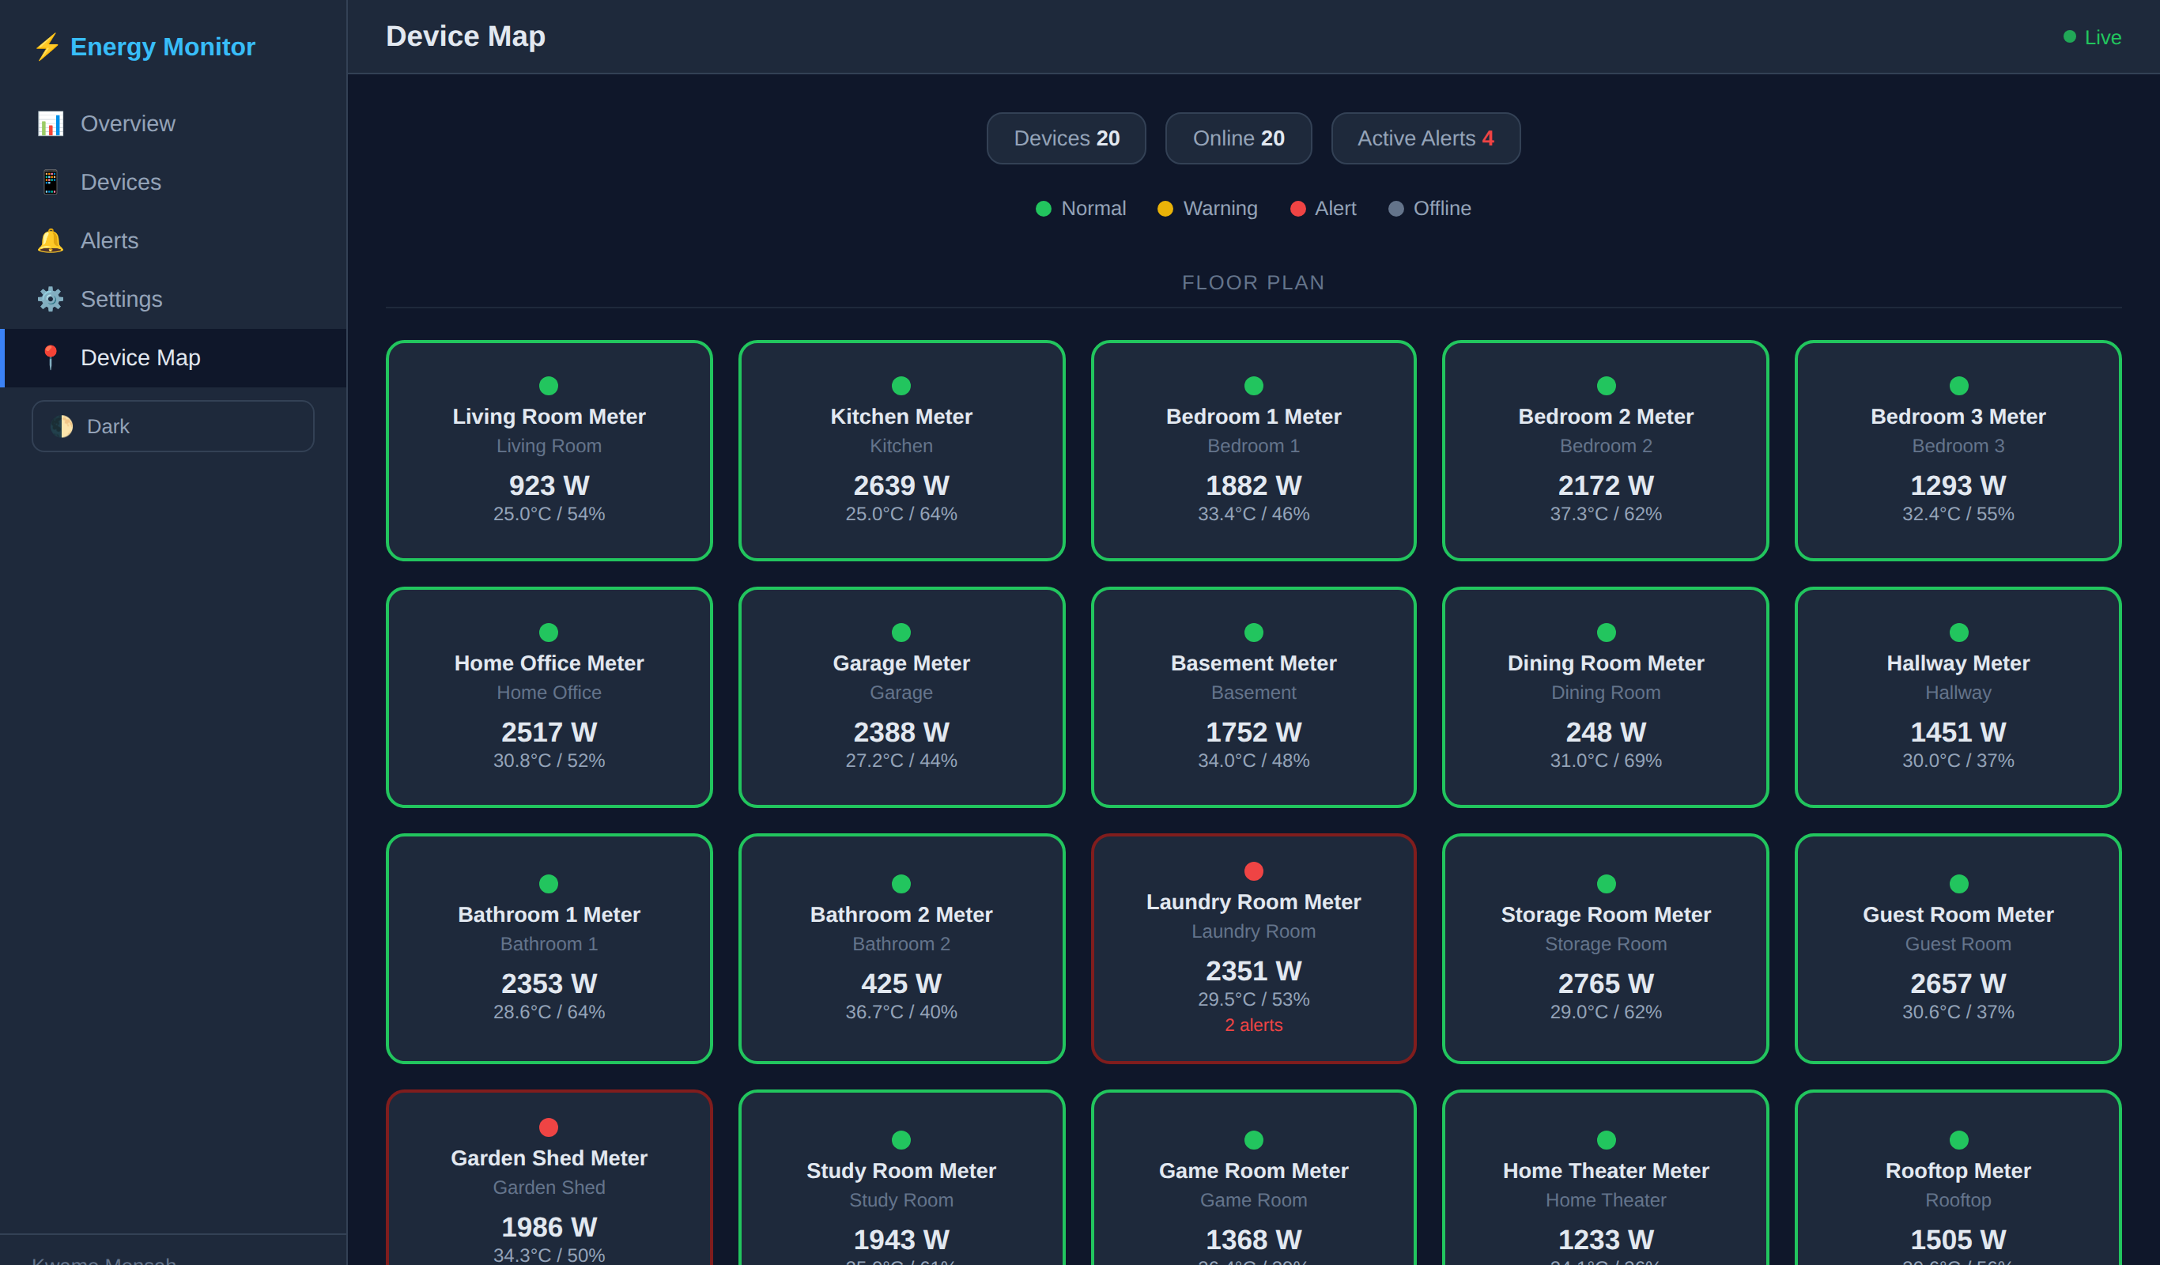
Figure 4.10: Device Map Interface
Description: This interface provides a location-based view of devices within the monitored environment, making it easier to identify where each smart meter is placed.
Test Performed: The map page was opened and checked to confirm that device locations matched the corresponding registered devices and were displayed correctly.
Result: Passed.
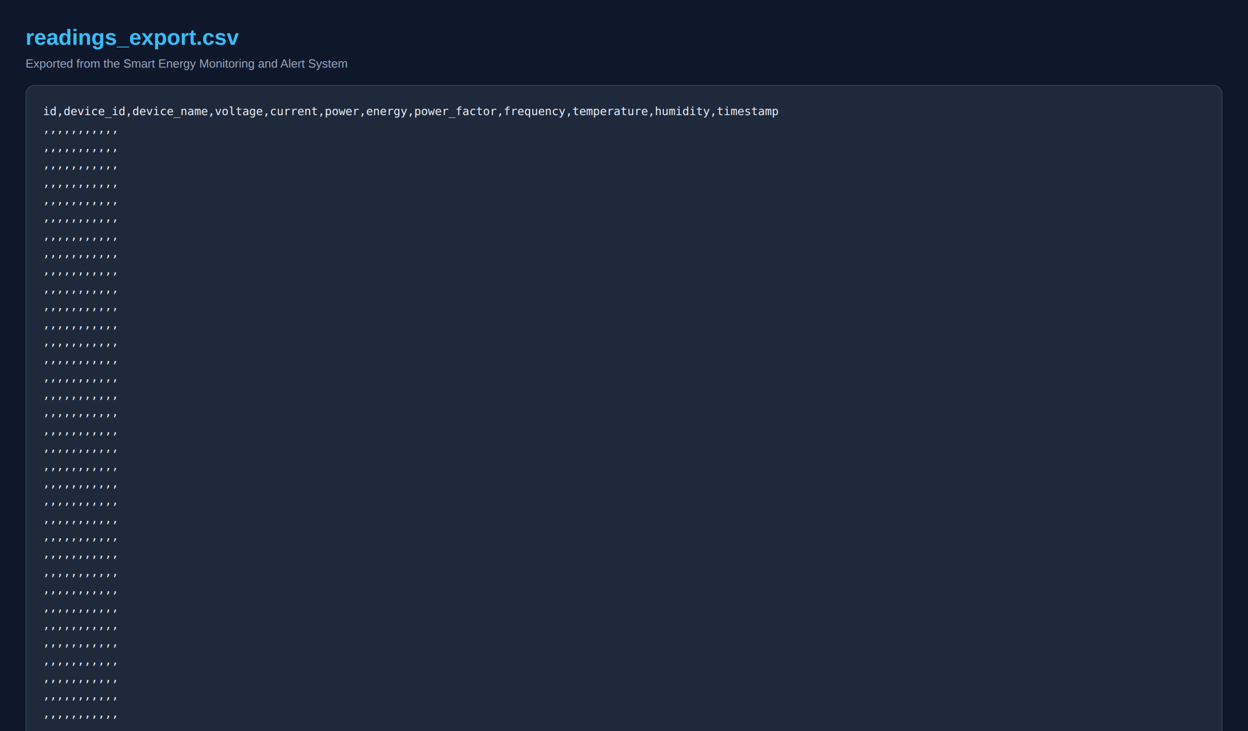
Figure 4.11: Data Export Interface/Output
Description: This screenshot shows the exported CSV output generated from the system for readings, alerts, or reports. It demonstrates that the system supports data extraction for further analysis and documentation.
Test Performed: Export buttons were used on the relevant pages and the downloaded CSV files were opened to verify that the records, headings, and values were correctly structured.
Result: Passed.
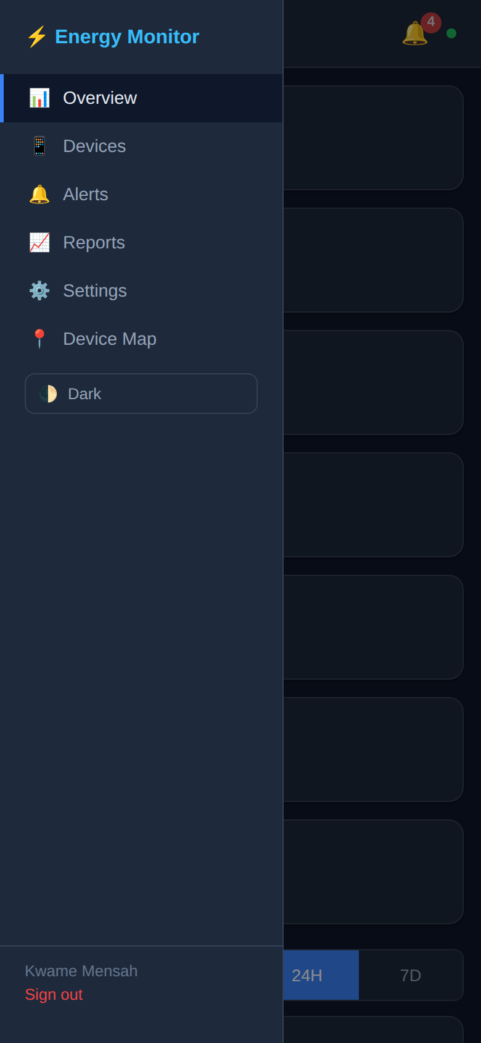
Figure 4.12: Mobile/Responsive Interface
Description: This interface shows the system running on a smaller screen size. It demonstrates that the application remains usable on mobile devices through responsive layout adjustments and navigation controls.
Test Performed: The dashboard was opened on a reduced viewport size and the sidebar toggle, cards, tables, and charts were checked for usability and proper layout adaptation.
Result: Passed.

Summary
The screenshots above confirm that the major interfaces of the Smart Energy Monitoring and Alert System were implemented successfully and tested across core functional areas including authentication, live monitoring, device management, alerts, reporting, settings, data export, and responsive access. All tested interfaces performed as expected.

